In attendance: Stephanie Fourie (vice-chairperson), Ned Panfile, Kevin Lanahan & Bruce DiBisceglie (Recreation Director). Charlotte Fourie (student representative)

- Communications
  - The July 2022 Mendham Borough Recreation Committee (MBRC) meeting minutes were approved as is.
    - Approved Minutes have been posted by Bruce to the Mendham Borough website.
  - Communications:
    - Day Camp:
      - Bruce submitted a list of camper refunds to Borough Clerk Carolynn Budd for the resolution to be presented at the next Borough Council Meeting on August 22.
    - Labor Day Event processing:
      - Carolynn is confirming dignitaries
      - Bruce is confirming marchers and bands
    - Food Truck Event processing:
      - Bruce has confirmed eight trucks for Oct 15 with Stuf’d (Rebecca Mitchell)
        - Susan Semrau is reviewing Rebecca’s contracts
      - Bruce confirmed the participation of the Black Horse Tavern with the manager.
      - Bruce has negotiated contract and confirmed for the “History of Rock & Roll” band
      - Bruce has confirmed the event’s sound company with Ultrascene Entertainment.
  - Meetings:
      - Borough Council postponed the July meeting to August 2.
        - Bruce could not attend the August 2 meeting due to a prior commitment for a medical procedure.
        - Minutes for the August 2 were not available at the time of this meeting.

- Labor Day Parade
  - Committee post assignments:
    - Bruce: VIP area Heritage Manor & East Main (to send groups, starting at 10:00am)
    - Kevin: Gazebo as Master of Ceremonies. Kevin may share duties with Joe D’Urso if Joe is available.
    - Ned: High School Parking lot to manage High School band, football team, and cheer team
    - Knights of Columbus: East Main & Tempe Wick
    - Diane: Tempe Wick
  - As of this meeting, 59% of the groups that have been invited have RSVPed
    - Confirmations: Color Guard: Boy Scouts Troop 1 Color Guard, Cub Scouts Troop 133, Grand Marshal - Neil Henry, Mayor Glassner and Council Andrews, Reilly & Sullivan, Former Mayor - Richard Kraft, Assemblywoman Aura Dunn, Morris County Surrogate - Heather Darling, Morris County Sheriff - James Gannon, Morris County Clerk - Ann Grossi, Morris County / Mendham Democrats, Rory O'Moore Pipe Band, Harvest Hustle, Alstead Farms, Denville String Band, Twin Boro Bears Cheerleaders, Twin Boro Bears Football, Mendham Area Girl Scouts Troop 6, Mendham High School Band, High School Varsity and JV Cheerleaders, Mendham Creamery, Mendham Library, Shore Brass Band , West Morris Soccer Club, Funny Factory, Backer Farms, Ralston Historical Association, Slattery Irish Dancers, Emerald Pipe Band, Mendham Chester Patriots Wrestling, Mendham Co-Op Nursery, St. Columcille Pipe Band, Doug's Flower Market, Grace Lutheran Church, Bloomingdale Cornet, West Morris Community Band, Mariachi Band, Knights of Columbus, and The Altman Brothers.
    - Invited, but have yet to respond: Police Car - Head of Parade - Chief Camoia / Father Mike, Borough Councilmen Andrew, Badal & Kelly, Morris County Commissioners (Stephen Shaw, Deborah Smith, Doug Cabana, Kathy DeFillippo, John Krickus, Tayfun Selen, Thomas Mastrangelo), Morris County / Mendham Republicans, Mendham Borough Fire Department, Mendham Borough First Aid Squad / EMT, Mendham Township Fire Dept (Brookside), Mendham Township Fire Dept (Ralston), Chester Fire Dept & First Aid, Randolph Fire Dept & Rescue Squad, Mendham Plywood, Mendham Magic Track and Field & Cross Country, Bernardsville Fire Dept & First Aid Squad, Hilltop Presbyterian Church & Nursery School, West Morris Youth Ice Hockey Club, Fairmount Fire Company (Long Valley), Weichert Realtors, Row New Jersey, Big Dog Rescue Project, and the Mendham Rotary Club
    - Three portable restroom facilities have been contracted by Bruce for Tempe Wick and East Main.

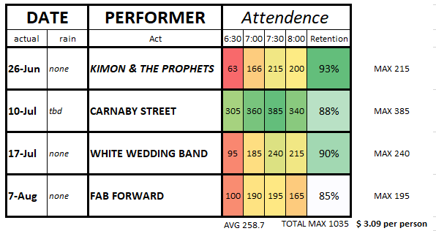
- Summer Events Wrap-Up
  - The Summer Concert Series concluded and was a success.
    - Total expenditure was $3,199 (on budget).
    - For the first time ever, the four concerts combined drew a peak attendance of over 1,000 people (approximately 1,035)
  - The combination event of Drive-In Movie and Day Camp Night Out, scheduled for July 28 was rained out. Day Camp could not reschedule. The MBRC decided that we will try for one movie next summer and evaluate the attendance/demand for movies have been declining.

- New Business
  - none.

- Old Business
  - The Mendham Girl Scouts Troop 6072 proposed a “Silver Award” plan to erect two tetherball poles next to the gaga pit in Borough Park was unanimously recommended for approval by the MBRC.
  - Chester Mendham Baseball & Softball Club did not attend this meeting to discuss concerting Lenape Field into a 50/70 field.

Next Meeting: 7:30 pm, Thursday, September 15th, 2022, at the Garabrant Center

